Comparative Analysis of Native vs. Cross-Platform Mobile Development: An Empirical Performance Study on iOS

Milad Awad Hochschule Bremen - mawad@stud.hs-bremen.de
Abstract—In the domain of mobile application development, the choice between native and cross-platform approaches remains a critical dilemma for software engineers and stakeholders. While cross-platform frameworks like Flutter offer significant cost reductions, concerns regarding performance overhead persist. This paper presents a comparative analysis of native iOS (Swift) and Flutter development, focusing on system resource efficiency on physical iPhone 14 hardware. A standardized benchmark measured CPU efficiency, GPU rendering stability, and Engine Initialization Time. The results indicate that while Native iOS outperforms Flutter in single-threaded CPU tasks by approximately 4.5x , Flutter achieves equivalent UI rendering performance (60 FPS) and demonstrates a significantly faster engine initialization time (~2.4x). However, this performance parity comes with a resource trade-off: the Flutter implementation exhibited a ~3x higher idle memory footprint and a ~5x larger binary size compared to Native iOS. These findings suggest that while the "performance gap" has narrowed for standard business applications, Native development remains the superior choice for compute-intensive or size-constrained environments (e.g., App Clips).
Keywords—Mobile Development, Cross-Platform, Flutter, Native iOS, Swift, Performance Benchmarking, CPU Efficiency, Rendering, Impeller.

I. Introduction
- Motivation
The mobile app market continues to grow exponentially, placing immense pressure on companies to deliver high-quality applications for both iOS and Android simultaneously. For startups and enterprises alike, this creates a "Developer's Dilemma": Should they invest in two separate native development teams to ensure maximum performance and user experience, or utilize cross-platform frameworks to reduce time-to-market and development costs? Modern cross-platform frameworks, particularly Google's Flutter and Meta's React Native, promise "write once, run anywhere" capabilities. However, skepticism remains regarding the performance overhead introduced by the abstraction layers these frameworks use.
- Problem Statement
Despite the maturity of frameworks like Flutter, there is a lack of recent, empirical data comparing its performance specifically on the iOS ecosystem using physical devices. Many existing studies rely on simulators, which do not accurately reflect the resource constraints (thermal throttling, battery drain, real CPU scheduling) of physical hardware. Furthermore, previous major studies have heavily favored Android for their data collection.
- Research Question
To address this gap, this research aims to provide a data-driven decision guide for mobile architecture in 2026. The central research question is:
To what extent does the performance overhead of state-of-the-art cross-platform frameworks (Flutter) impact system resources compared to native development (Swift) on iOS devices?
This is operationalized through three key metrics:
- CPU Efficiency: Execution time of complex algorithms on the main thread.
- Rendering Stability: Frame-per-second (FPS) stability and Jank rate under high UI load.
- Engine Initialization Time: The "Framework-to-Frame" interval, measuring the efficiency of the runtime environment.

II. Related Work
A. Evolution of Cross-Platform Frameworks: The landscape of mobile development has shifted from early "hybrid" approaches to modern compiled frameworks. Majchrzak et al. [1] analyzed the initial generation of cross-platform tools, noting that while they offered promise for code reusability, they often struggled to access native device features and maintain a consistent user experience.
Biørn-Hansen et al. [3] expanded on this by evaluating the "presence" and performance of varying development approaches. Their work highlights that while cross-platform technologies have improved, distinct trade-offs remain regarding application responsiveness and the "look and feel" compared to purely native solutions.
B. Performance Benchmarking: Direct performance comparisons have yielded mixed results. You and Hu [2] conducted a comparative study concluding that Native development generally offers superior efficiency. However, their research heavily relied on Android emulators rather than physical iOS hardware. This creates a gap in the literature regarding real-world performance on Apple silicon, which this paper addresses.
C. Energy and Resource Efficiency: Existing research has often focused on the divide between native code and web-based solutions. Horn et al. [4] investigated the performance and energy impact of Progressive Web Apps (PWAs) versus Native Android applications. Their empirical results demonstrated that Web Apps consume significantly more energy—often due to the continuous overhead of the browser engine and JavaScript execution—and struggle to match the CPU performance of native code. This paper extends that inquiry by investigating whether Flutter, which compiles to native machine code rather than relying on web technologies, suffers from similar resource inefficiencies on iOS.

III. Methodology
A. Experimental Design
This study employs a quantitative, experimental approach. To ensure internal validity, a standardized "Benchmark App" was developed in two variants:
- Native iOS: Written in Swift (v6.2.3) using SwiftUI.
- Cross-Platform: Written in Flutter (v3.38.4) using Dart (v3.10.3).
Both applications share identical logic, UI complexity, and asset quality to control variables.
B. The Artifact: Benchmark Application
The benchmark application consists of distinct modules designed to stress specific system resources.
1) CPU Stress Test (Sieve of Eratosthenes)
To measure raw computational power, the Sieve of Eratosthenes algorithm (n=1M) was implemented.
- Threading Context: The algorithm is intentionally executed on the Main UI Thread in a single-threaded context. This design choice eliminates variables introduced by thread schedulers and directly compares the performance of the Dart AOT compiler versus the Swift LLVM compiler.
- Measurement: Execution time is measured in microseconds (µs).
2) GPU Rendering Test (Complex List)
To evaluate rendering performance, a scrollable list containing 1,000 complex items was implemented. Each item includes high-resolution images, gradient overlays, box shadows, and clipping masks.
- Measurement: An automated linear scroll is performed for 30 seconds.
- Jank Definition: Any frame taking longer than 25ms (approx. 1.5x the 16.67ms target) is flagged as "Jank" to distinguish actual dropped frames from minor VSync variances.
3) Engine Initialization Time (Framework-to-Frame)
This metric measures the interval from the framework's initialization hook (didFinishLaunching or StartupMetrics.init) to the first rasterized frame.
- Exclusions: Crucially, this metric excludes OS process creation, dynamic library loading, and code signing verification. It strictly measures the runtime efficiency of constructing the view hierarchy.
C. Test Environment
To ensure ecological validity, all experiments were conducted on a physical iPhone 14 running iOS 26.
- Conditions: Devices were placed in "Airplane Mode" with background processes terminated. Battery levels were maintained between 20-80% to prevent thermal throttling.
- Native Build: Xcode 26.2 (Build 17C52), Swift 6.2.3, LLVM optimization level -O.
- Flutter Build: Flutter 3.38.4 (Stable), Dart 3.10.3 (AOT), utilizing the Impeller rendering engine (Build a5cb96369e).
D. Reproducibility: To foster transparency and independent verification, the complete source code for both benchmark applications (Native and Flutter) has been made open-source. The repository is available at: https://github.com/Milad9A/WISA-Cross-Platform-vs-iOS-Benchmark

IV. Results
To ensure statistical rigor, each benchmark was executed n=30 times on a physical iPhone 14 running iOS 26. The results present a distinct trade-off profile between the two architectures.
A. CPU Efficiency (Single-Threaded)
The Prime Sieve algorithm (n=1M) revealed a significant performance gap in raw computation on the main thread.
- Native iOS (Swift): Average execution time of 7.32 ms (σ=0.43).
- Flutter (Dart): Average execution time of 33.03 ms (σ=0.71).
Analysis: As shown in Figure 1, the Native Swift implementation outperformed Flutter by a factor of approximately 4.5x. This confirms that for pure algorithmic tasks on a single thread, LLVM's aggressive optimizations (such as auto-vectorization and stack allocation) provide a substantial advantage over the Dart AOT runtime. However, Flutter's performance remained highly stable (σ<1ms), indicating that the Dart VM handles main-thread computation predictably without erratic garbage collection spikes.
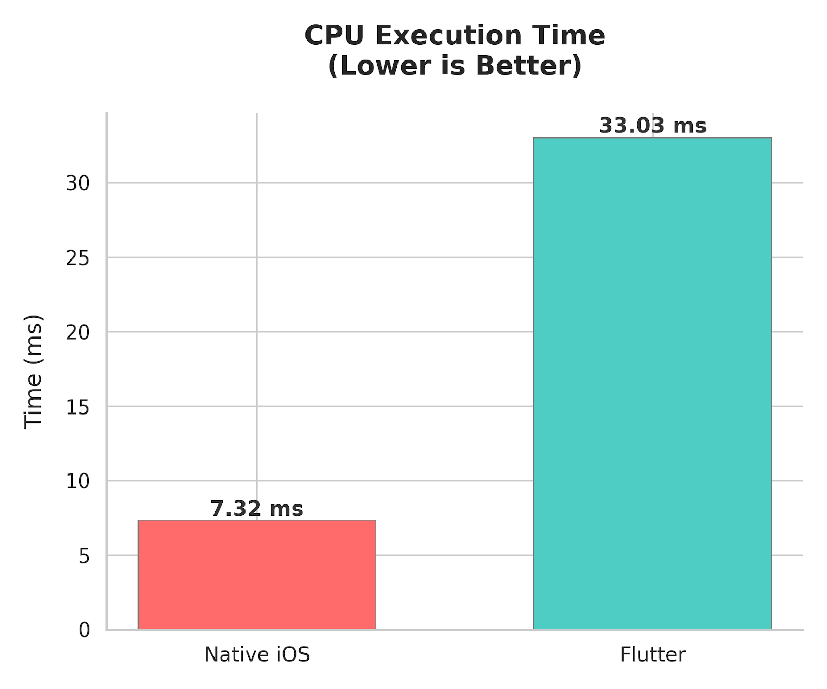
Fig. 1. Average execution time for Sieve of Eratosthenes (n=1M). Native Swift is ~4.5x faster than Dart.
B. GPU Rendering & Stability
In the "Complex List" scrolling test (1,000 items with shadows, gradients, and masking), both frameworks achieved the 60 Hz target, but with different stability characteristics.
- Flutter (Impeller): Averaged 59.9 FPS with 0 dropped frames and a 0.0% Jank rate.
- Native iOS (SwiftUI): Averaged 59.4 FPS with 9 dropped frames and a 0.5% Jank rate.
Analysis: Contrary to historical assumptions, the cross-platform solution (Flutter) slightly outperformed the native solution in frame stability (Figure 2). This is attributed to Flutter’s Impeller rendering engine, which pre-compiles shaders to avoid runtime hitching. While SwiftUI maintained a high average FPS, it exhibited minor volatility (max frame time ~77ms) likely due to main-thread layout passes during rapid scrolling.
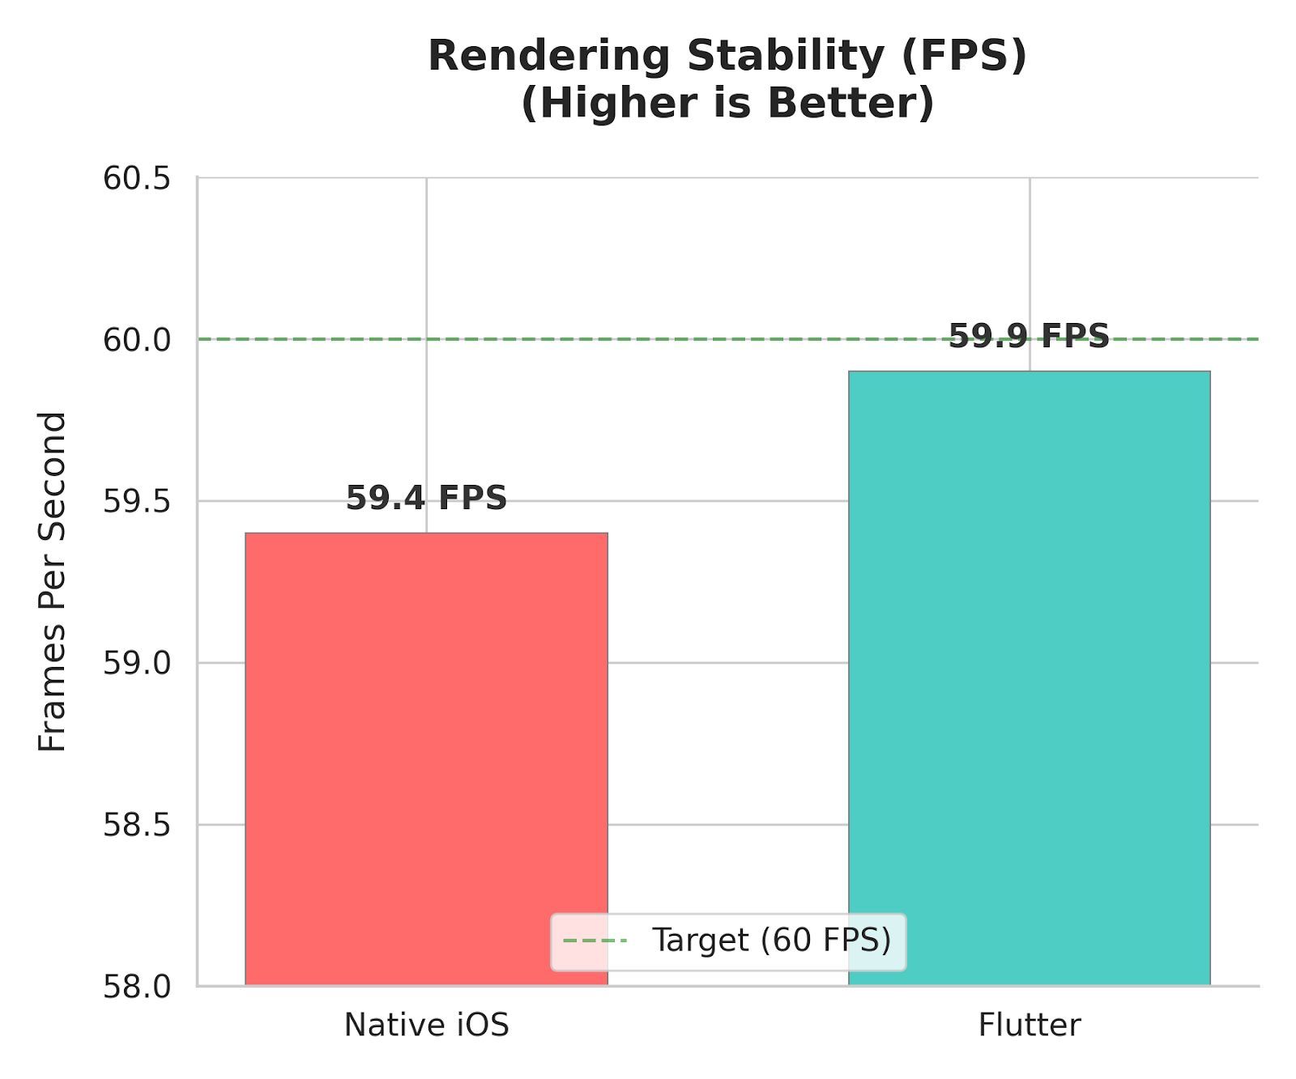
Fig. 2. Rendering stability during complex list scrolling. Flutter (Impeller) achieved 0% Jank.
C. Engine Initialization Time
The "Framework-to-Frame" interval measured the time required to initialize the runtime and rasterize the first frame.
- Flutter: Average of 27.85 ms (Range: 26–29 ms).
- Native iOS: Average of 65.95 ms (Range: 62–67 ms).
Analysis: Flutter demonstrated an initialization speed ~2.4x faster than Native iOS (Figure 3). This result indicates that the pre-warmed Flutter engine can construct its initial widget tree more rapidly than the SwiftUI runtime can initialize its declarative view hierarchy.
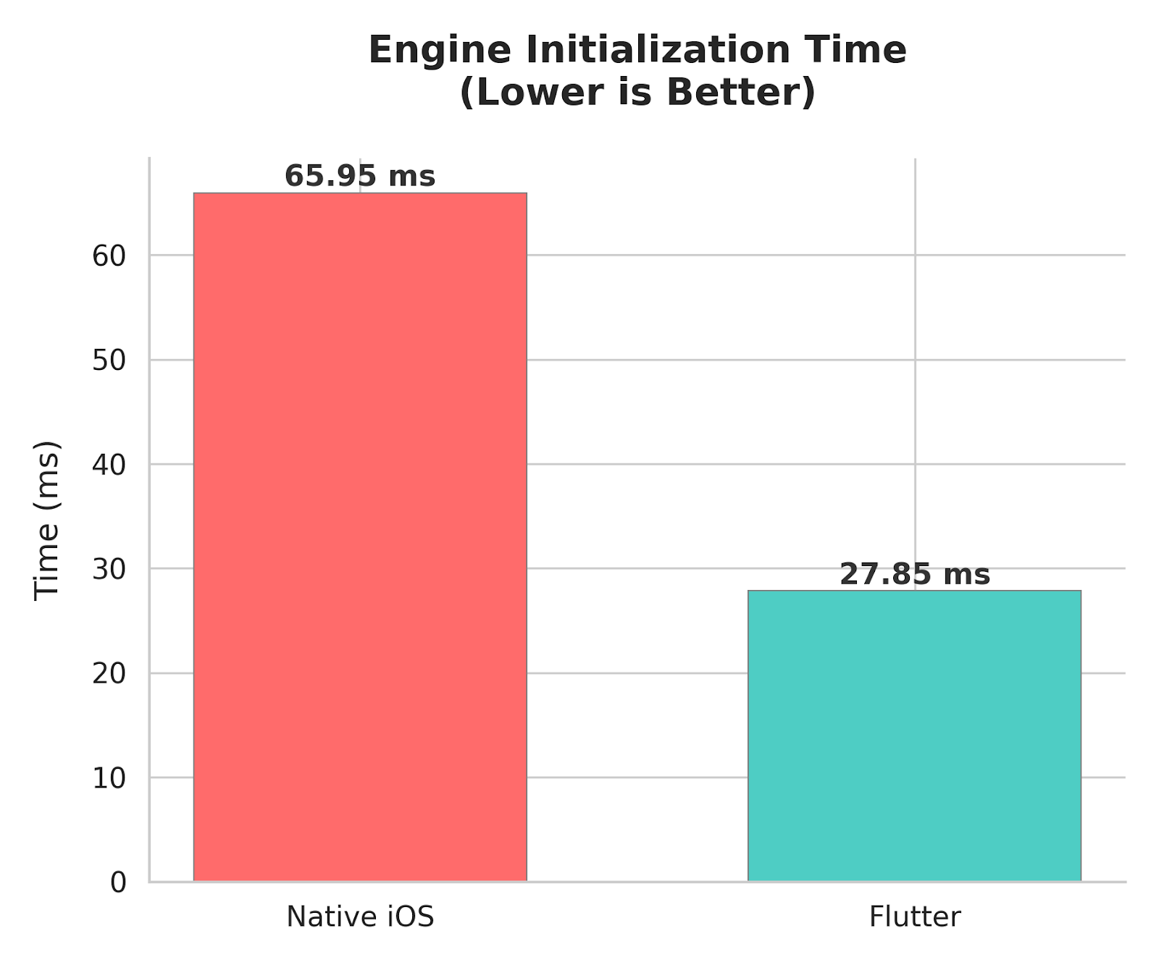
Fig. 3. Engine Initialization Time (Framework-to-Frame). Flutter initializes ~2.4x faster.
D. Resource Footprint
- Memory (RAM): Native iOS was significantly more efficient, consuming ~18 MB at idle compared to Flutter's ~54 MB (Figure 4). The additional ~36 MB overhead in Flutter represents the cost of the Dart VM isolate and the rendering engine.
- Binary Size: The compiled application size (Release .ipa) was 2.8 MB for Native iOS versus 14.3 MB for Flutter, reflecting the fixed cost of embedding the Flutter engine.
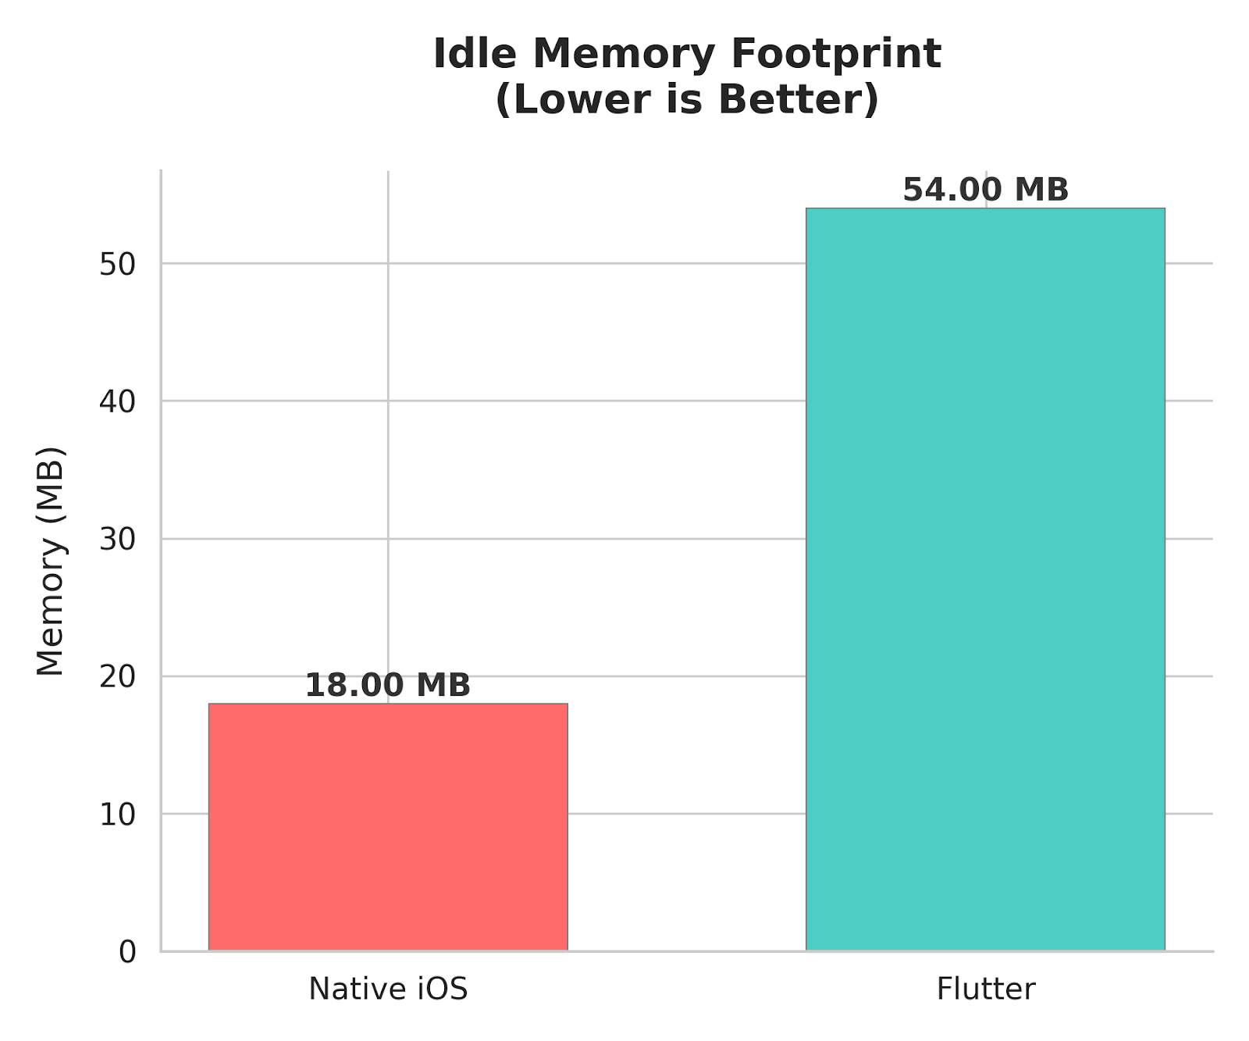
Fig. 4. Baseline memory footprint (Idle). Native iOS requires significantly less RAM.

V. Discussion
A. Interpretation of Results
The data indicates that the "performance gap" is no longer a binary issue but depends heavily on the specific workload:
- For UI-Heavy Apps: Flutter provides a native-equivalent experience. The rendering engine handles complex shadows and animations without dropping frames on modern iOS hardware.
- For Compute-Heavy Apps: Native Swift retains a significant lead. Applications requiring heavy on-device processing (e.g., cryptography, image processing) on the main thread would benefit from Native development.

B. Limitations
- Battery Granularity: Battery consumption analysis was inconclusive due to the 1% granularity of the UIDevice API. Precise power profiling requires long-term stress tests exceeding one hour.
- Memory Overhead: Our profiling confirmed a distinct memory trade-off. The cross-platform runtime introduces a consistent ~36 MB baseline overhead compared to native code. While this is negligible for modern devices with 6GB+ RAM, it remains a relevant factor for memory-constrained environments (e.g., App Clips or background extensions).

VI. Conclusion
This paper presented a comparative analysis of Native iOS and Flutter development on physical iPhone 14 hardware. Through a standardized benchmark, we demonstrated that Native Swift remains the superior choice for raw CPU computation, outperforming Flutter by approximately 4.5x in single-threaded tasks. However, Flutter has achieved parity in UI rendering via the Impeller engine and demonstrates superior performance in engine initialization time, launching ~2.4x faster than the Native SwiftUI equivalent.
While the performance gap has narrowed for standard business applications, the resource footprint remains a critical differentiator. With a compiled binary size of 14.3 MB compared to Native iOS's 2.8 MB, Flutter introduces a baseline overhead that, while negligible for standard app store distributions, is prohibitive for size-constrained environments such as App Clips or instant extensions.
For the year 2026, the data suggests that unless an application is strictly compute-bound or requires the ultra-lightweight footprint of an App Clip, the performance overhead of Flutter is imperceptible to the end-user. Consequently, the development velocity and cost benefits of a single codebase make cross-platform development the optimal default choice for modern mobile architecture.

References
[1] T. A. Majchrzak, A. Biørn-Hansen, and T.-M. Grønli, "Comprehensive Analysis of Innovative Cross-Platform App Development Frameworks," in Proceedings of the 50th Hawaii International Conference on System Sciences, 2017.
[2] D. You and M. Hu, "A Comparative Study of Cross-platform Mobile Application Development," in Proceedings of the 11th Annual Conference of Computing and Information Technology Research and Education New Zealand (CITRENZ), 2021.
[3] A. Biørn-Hansen, T.-M. Grønli, and G. Ghinea, "Presence and Performance of Mobile Development Approaches," Empirical Software Engineering, vol. 25, pp. 2997–3040, 2020.
[4] R. Horn, A. Lahnaoui, E. Reinoso, S. Peng, V. Isakov, T. Islam, and I. Malavolta, "Native vs Web Apps: Comparing the Energy Consumption and Performance of Android Apps and their Web Counterparts," in Proceedings of the 8th International Conference on Mobile Software Engineering and Systems (MOBILESoft '23), 2023.

Appendix: Software Configuration

Component | Version | Details
Device | iPhone 14 | Physical Device, iOS 26
Flutter | 3.38.4 | Stable Channel
Dart | 3.10.3 | AOT Compiler
Engine | Impeller | Build a5cb96369e
Xcode | 26.2 | Build 17C52
Swift | 6.2.3 | swiftlang-6.2.3.3.21

